

eDome ESS Management Platform

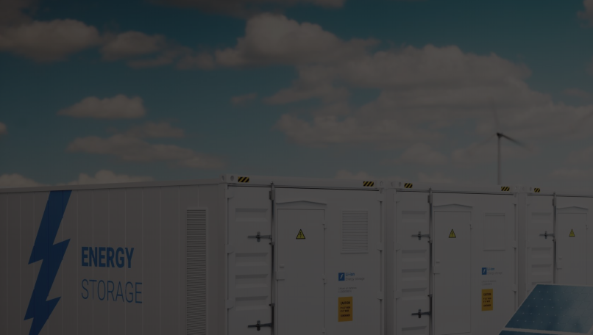
EAEMS-DM919 is an integrated energy management solution specifically engineered for large-scale energy storage facilities with capacities ranging from 100 MWh to the GWh level.
Capable of processing massive volumes of monitoring data, ensuring rapid response, and supporting diverse operational modes, this system delivers real-time monitoring, intelligent scheduling, comprehensive analysis, and efficient maintenance. It safeguards the safe, reliable and stable operation of energy storage stations.

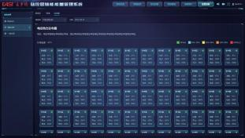
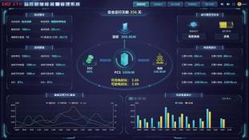

Produc Model | EAEMS-DM919
Maximum Access Capacity | 1GWh
Historical Data Storage Time | ≥ 2 years (5-minute interval)
Annual Availability of Dual-System | ≥99.9%
Service Life | ≥10 years
Backup Requirements | Dual-machine & dual-network redundancy; core files and databases with mirror backup.
Operating Strategies | Primary Frequency Regulation, Dynamic Reactive Power Voltage Regulation, Inertia Support, Precise Load Shedding, Dispatch Operation, Scheduled Curve, Power Fluctuation Smoothing, Peak Shaving and Valley Filling, Demand Management, Anti-backflow Protection, PV-Storage Coordination.
Primary Frequency Regulation Response Time* | ≤20ms
Secondary Frequency Regulation Response Time* | ≤20ms
Communication Protocol | IEC61850、IEC104、MODBUS TCP etc.
Application Scenarios | Large-scale energy storage, PV-storage projects, industrial and commercial energy storage, microgrids, etc.
*From measured value entering operating region to device output of downstream control command.

Intelligent and efficient
- SOC Intelligent Balancing to Reduce Battery Capacity Loss
- Panoramic monitoring, comprehensive cell data tracking, real-time fault alerts and precise fault location
- Big Data Analysis and Artificial Intelligence Algorithm Technologies.

Quick Response
- Our 3S core systems（EMS, PCS and BMS）are fully independently developed. Boasting direct data acquisition and transmission, the solution delivers a remarkable boost to system response speed.
- Primary frequency modulation response time: ≤ 20 ms
- Second-scale data acquisition and storage

Panoramic Coverage
- The system delivers panoramic coverage of core operational scenarios.
- Featuring panoramic monitoring & coverage, it enables full-scope battery data tracking and fault alerts.

Reliability & Stability
- Independent Redundant Four-Network Architecture – Separated Control & Data Networks.
- Redundant critical equipment with seamless failover guarantees secure and stable operation of the entire system.

EAST Digital Energy Technology Co., Ltd.
——————
Address：No. 70 Jinye Road, High-tech Industries Development Zone, Xi'an, Shaanxi, P.R.China
Tle:+86-769-22897777-8313
Email:zhny@eastups.com

